Task 9: Intelligent Chatbot System
Aim:
To build an intelligent chatbot system with Python and Dialogflow using an interactive text mining framework for exploring semantic flows in a large corpus of text.

Algorithm:
Steps to create an intelligent chatbot using OpenAI APIs:
- Sign up for OpenAI API access at https://platform.openai.com/signup.
After signing up, generate your API key.
- Choose the chatbot type — e.g., FAQ chatbot, customer support bot, or general conversational bot.
- Use OpenAI’s GPT model to generate responses to user input.
- Apply Natural Language Processing (NLP) to understand user intent and extract entities.
- Use Machine Learning to continuously improve chatbot responses.
- Integrate the chatbot with any platform (like a website or social media) using APIs.
- Test and refine the chatbot based on user feedback.

Program a: Simple ChatGPT using OpenAI
# Install the OpenAI library (run this once)
# pip install openai

from openai import OpenAI

client = OpenAI(api_key="YOUR_API_KEY_HERE")

completion = client.chat.completions.create(
model="gpt-3.5-turbo",
messages=[
{"role": "user", "content": "Give me 3 ideas that I could build using OpenAI APIs"}
]
)

print(completion.choices[0].message.content)
Sample Output:
1. Personalized Content Recommendation System
2. Intelligent Chatbot for Customer Support
3. Fraud Detection System for E-commerce

Program b: ChatGPT Assistant (Interactive Console Chatbot)
from openai import OpenAI

client = OpenAI(api_key="YOUR_API_KEY_HERE")

messages = []
system_msg = input("What type of chatbot would you like to create?\n")
messages.append({"role": "system", "content": system_msg})

print("Your new assistant is ready! Type your query (type 'quit()' to exit)")

while True:
message = input("You: ")
if message.lower() == "quit()":
break

messages.append({"role": "user", "content": message})
response = client.chat.completions.create(
model="gpt-3.5-turbo",
messages=messages
)

reply = response.choices[0].message.content
messages.append({"role": "assistant", "content": reply})
print("\nAssistant:", reply, "\n")
Sample Output:
What type of chatbot would you like to create?
Nila’s personal chatbot
Your new assistant is ready! Type your query (type 'quit()' to exit)
You: Hello!
Assistant: Hi there! How can I help you today?

Program c: Chatbot Web Interface using Gradio
# Install dependencies first:
# pip install openai gradio

from openai import OpenAI
import gradio as gr

client = OpenAI(api_key="YOUR_API_KEY_HERE")

messages = [{"role": "system", "content": "You are a financial expert specializing in real estate investment and negotiation."}]

def CustomChatGPT(user_input):
messages.append({"role": "user", "content": user_input})
response = client.chat.completions.create(
model="gpt-3.5-turbo",
messages=messages
)
reply = response.choices[0].message.content
messages.append({"role": "assistant", "content": reply})
return reply

demo = gr.Interface(fn=CustomChatGPT, inputs="text", outputs="text", title="INTELLIGENT CHATBOT")
demo.launch(share=True)
Sample Output (Web Interface):
A chat window opens in the browser where the user can interact with the chatbot.
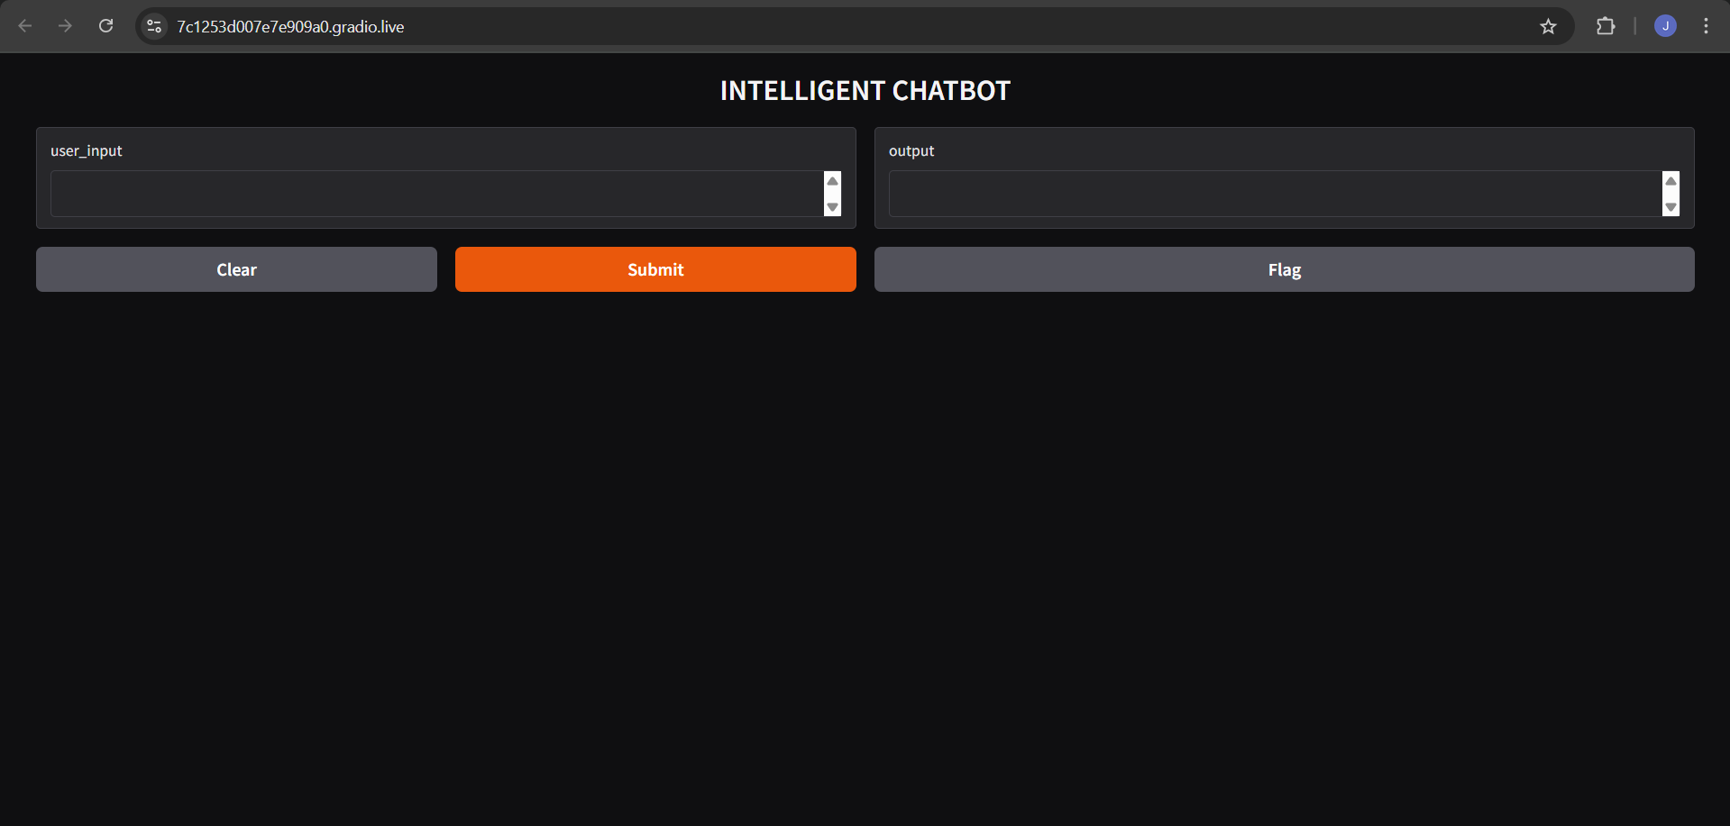

Result:
Thus, the intelligent chatbot system was successfully built using Python and Dialogflow (OpenAI API). The chatbot was able to process user queries, generate intelligent responses, and provide interaction through both console and web interfaces.

